
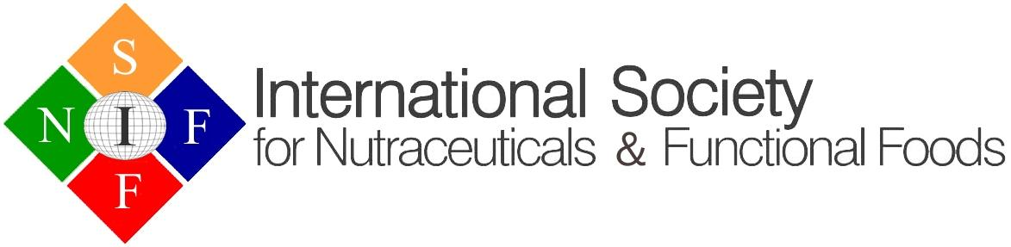

International Conference and Exhibition on
Nutraceuticals and Functional Foods (2025)
Ho Chi Minh City, Vietnam
September 14-17, 2025
Post Conference Activities September 18-20, 2025 (On-site Arrangements)

First Name: |  | Middle Name:
Family Name: |  | (Dr., Mr., Ms.):
*Affiliation:

Address:

Email: |  | Tel:
Categories | Until July 14, 2025 |  | After July 14, 2025
Member | US$495 |  | $575
Non-member | $575 |  | $645
Student member | $245 |  | $295
Student non-member | $295 |  | $325
Accompanying person | $100 |  | $100
Exhibitor (Triple Table Top) | $2,000 - 2 complementary registrations
Exhibitor (Table Top) | $1,000 - 1 complimentary registration
Gala Dinner | $85

Total amount: US $

Payment:
Certified Cheque: Payable to ISNFF
Credit Card: VISA MASTERCARD

Credit Card #:
CVV:
Expiry Date:
Card Holder:

(Please email to: ISNFFsecretary@gmail.com).
Note: Local Vietnamese presenters and participants to register as per separate instruction
Registration includes lunch during the conference

